CO2-AT1
NAME: S.Likiteshwar Reddy
Reg no: 192425120
Course: MLA0404 - Deep Learning

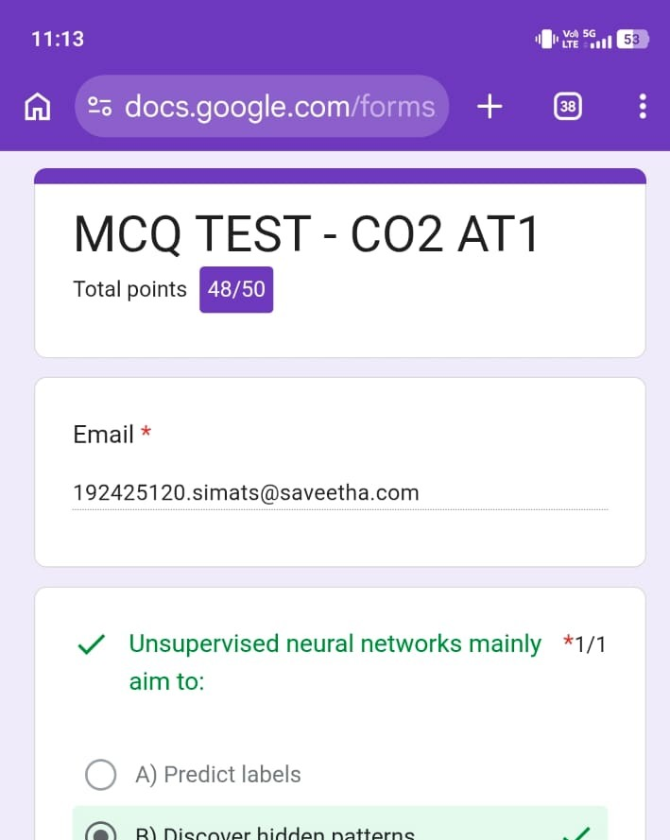

Quiz Achievement
I successfully completed the CO2-AT1 Deep Learning quiz and scored 48/50.
This result reflects my understanding of the course concepts and my consistent preparation.

